What is Student Y?

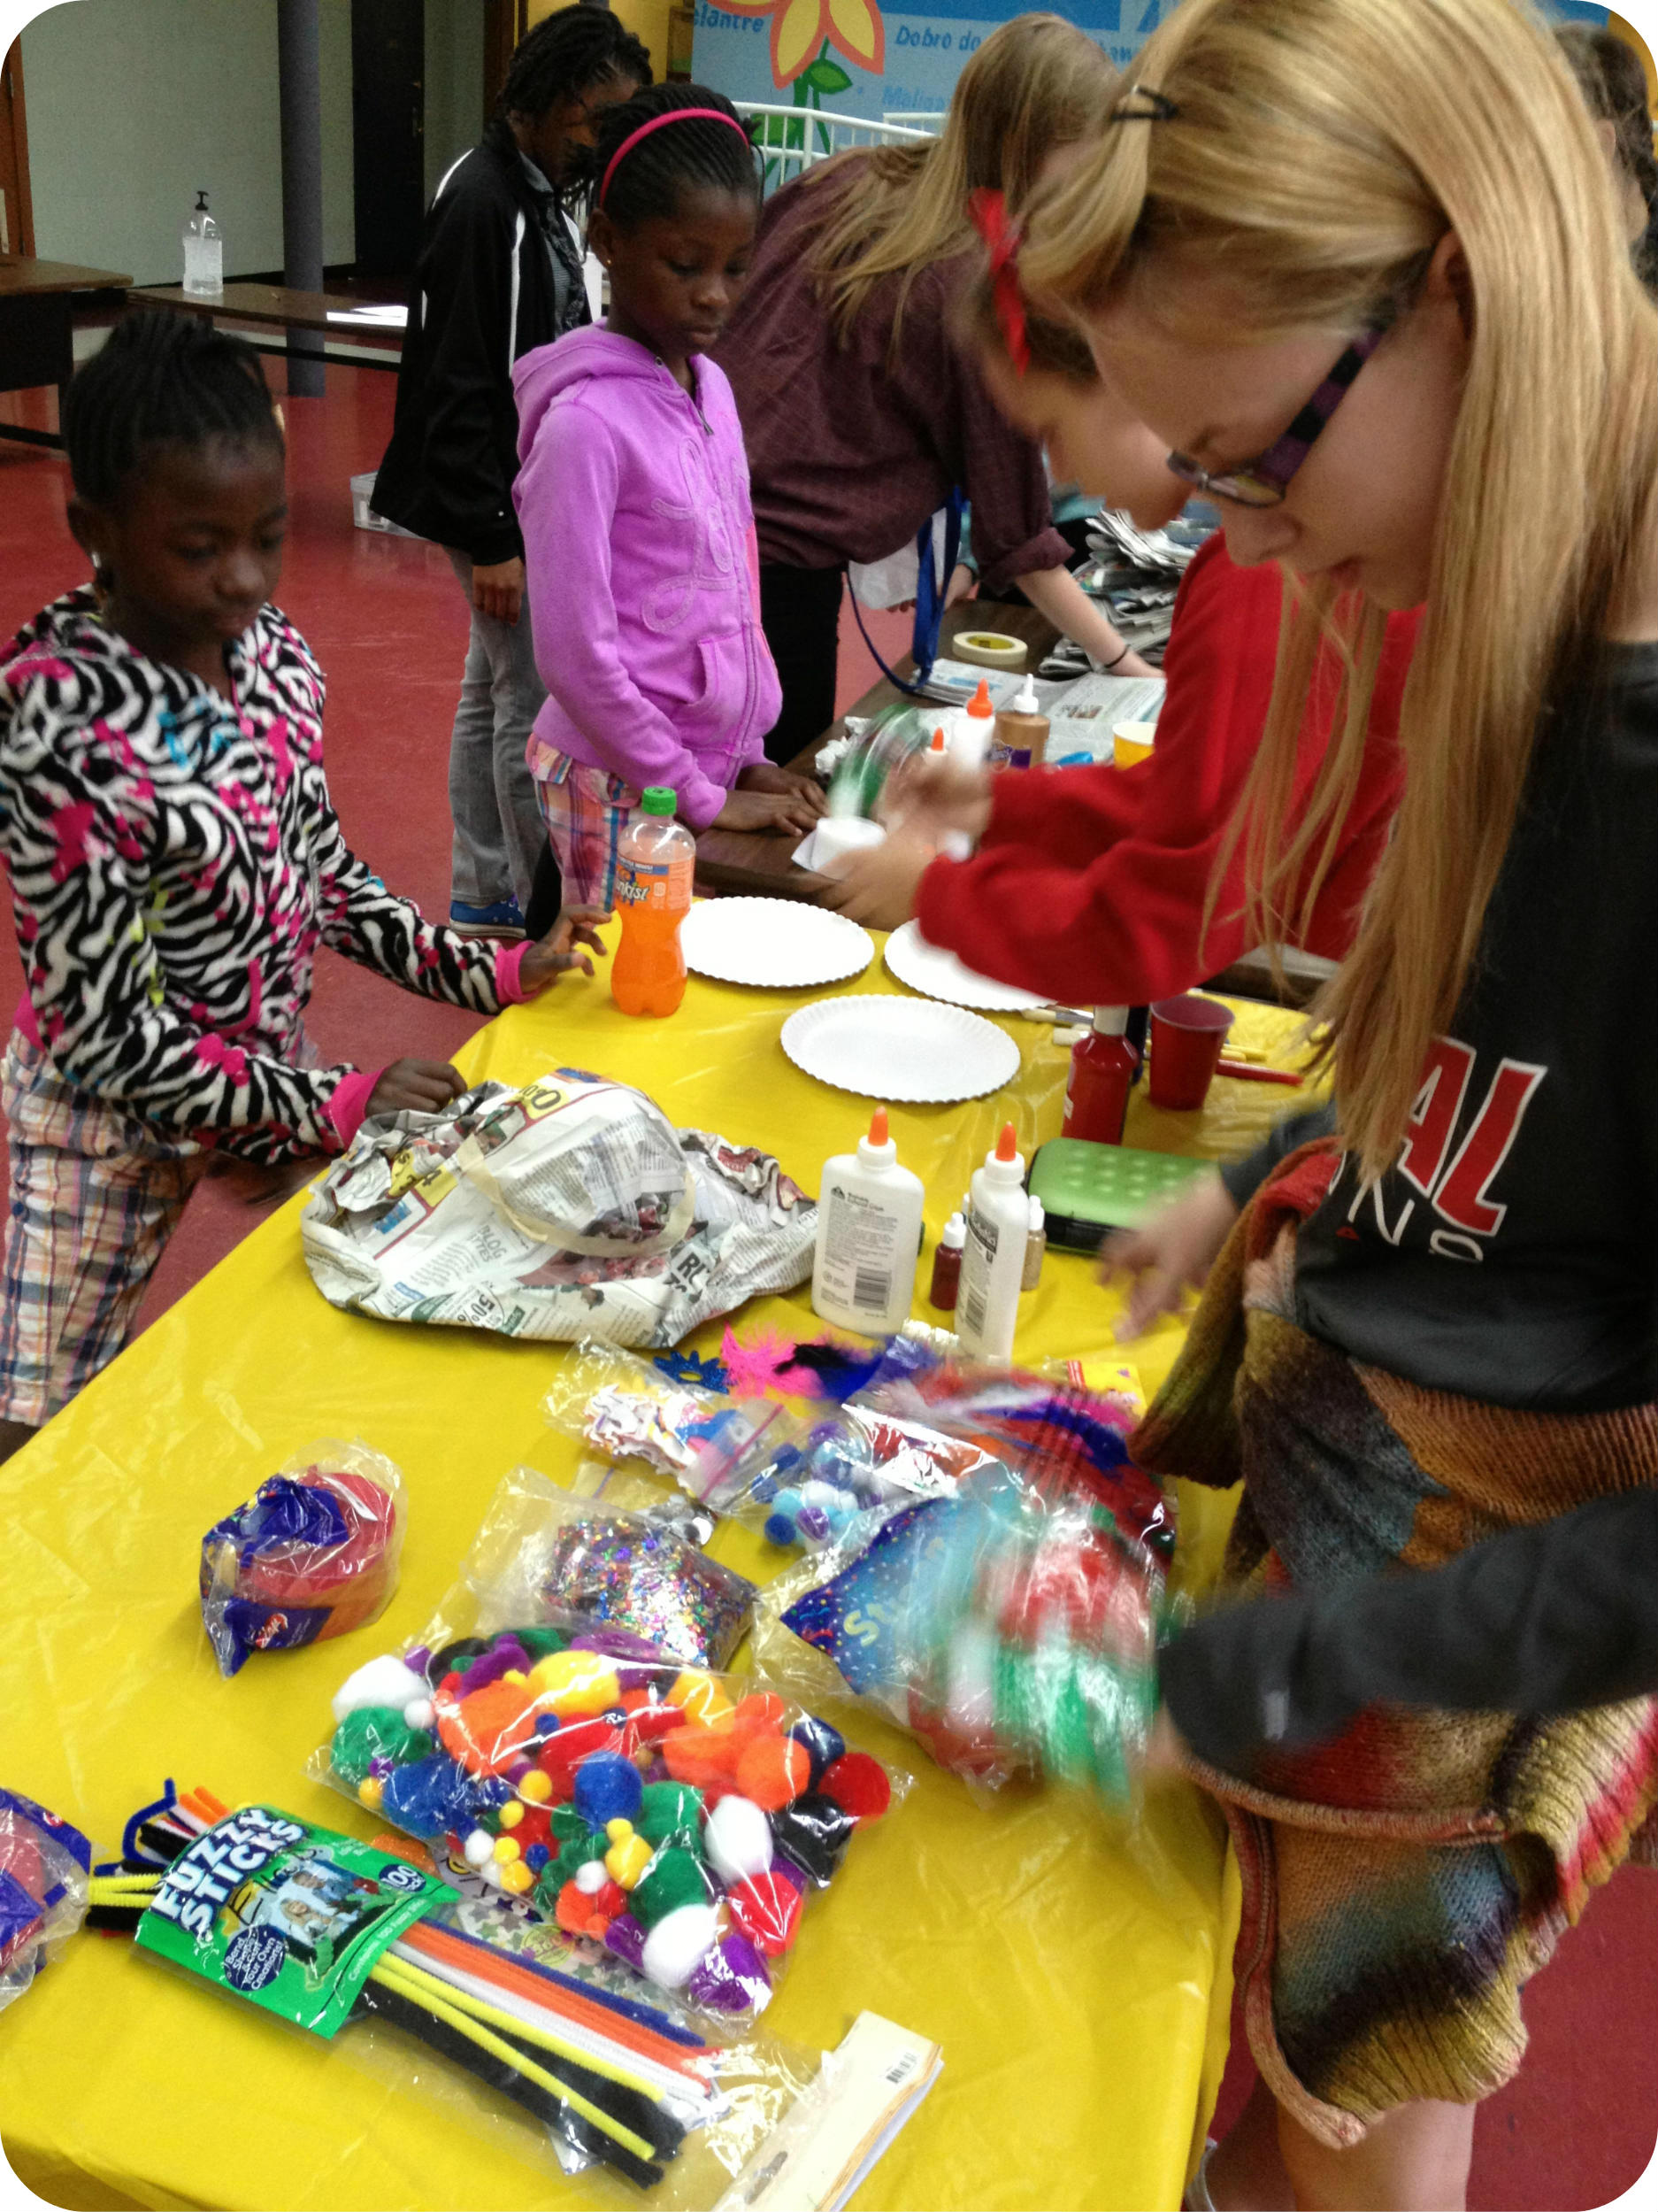
The Student Y is a student-run school or community-based organization that promotes critical thinking, leadership, and social responsibility through experiential learning, service, and community activism in fellowship with peers, caring adults, and YMCA staff.

Along with participating in multiple acts of service throughout the year, Student Ys participate in a service project in the fall that focuses on their community, and a project in the spring that focuses on the world. Beyond this, Student Ys choose the level of involvement that is best for their participants. Student Y encourages all 6th-12th graders to participate in the democratic process while cultivating a sense of civic duty and social responsibility through service learning.

Members of the Student Y focus on improving their school, community, state, and world through hands on, student-led service projects based around issues about which they are passionate.

Service

Each year the KY Y staff will recommend a particular service project for the fall and spring. These recommendations will be made so that all Student Ys are able to have resources readily available to them to plan a project with the help of Y staff. Although we are making service recommendations, we still encourage Student Ys to do as many projects as they would like, and the projects that best fit them.

Why Student Y?

Benefits to students:
- Allows students to develop and demonstrate competence in several Kentucky Core Academic Standards including:
  - 1.11: Students write using appropriate forms, conventions, and styles to communicate ideas and information to different audiences for different purposes
  - 2.14: Students understand the democratic principles of justice, equality, responsibility and freedom and apply them to a real life situation
  - 2.17: Students interact effectively and work cooperatively with the many ethnic and cultural groups of our nation and world
  - 3.3: Students demonstrate the ability to be adaptable and flexible through appropriate tasks and projects
  - 3.6: Students demonstrate the ability to make decisions based on ethical values
  - 4.3: Students individually demonstrate consistent, responsive, and caring behavior
  - 4.4: Students demonstrate the ability to accept the rights and responsibilities for self and others
  - 5.2: Students use creative thinking skills to develop or invent novel, constructive ideas or products
  - 5.4: Students use a decision-making process to make informed decisions among options
  - 6.1: Students connect knowledge and experiences from different subject matters
The list above corresponds to the Academic Expectations of the Kentucky Core Academic Standards

Why Student Y? (continued)
- Provides students an opportunity to develop College and Career Readiness Skills (CCR) in the following areas:
  - Comprehension and Collaboration
  - Presentation of Knowledge and Ideas
  - Knowledge of Language

- Helps students to identify Sparks, or areas where passion, motivation, and skill intersect leading to future orientation and a sense of empowerment
- Encourages students to develop cultural competencies through peer learning
- Enables students to establish inclusive networks of peers and friends throughout the state
- Provides access to many of the 40 Developmental Assets identified by the Search Institute as crucial to adolescent success. http://www.search-institute.org/content/40-developmental-assets-adolescents-ages-12-18

Benefits to schools:
- Helps to develop an internal network of skilled and passionate student leaders
- Establishes or improves a culture of servant leadership
- Connects schools to community resources interested in working on behalf of students

Resources:
- Access to a network of motivated student leaders around the state
- Training on effective leadership and group management
- Resources for planning and executing service-learning projects
- Resources for effective fundraising

Recommended Officer Positions and Tasks:
All Student Ys can choose which youth officer positions will best serve their club, however the KY Y has provided examples of what these roles can look like. The KY Y encourages all officer positions to be in place by the end of September each year. These positions can be combined as seen fit by the club.

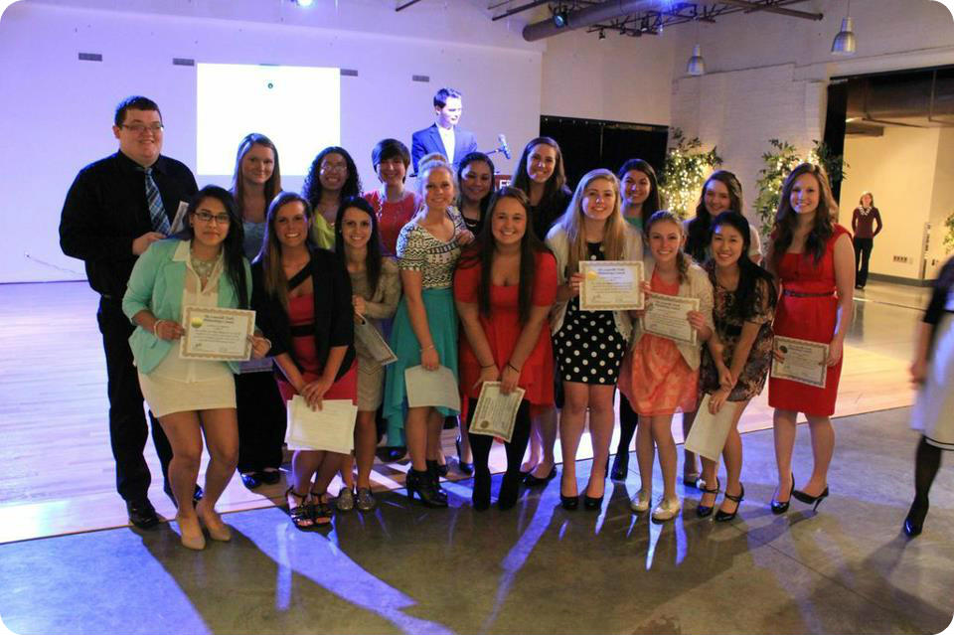
In order to recognize the amount of hard work that every Student Y completes throughout the year, officer communication with advisors and KY Y staff is extremely important. By maintaining consistent communication with advisors and the KY YMCA, youth officers will help their club have fun, stay organized, keep track of service and participation, and keep the service goal of Student Y at the forefront of the club.

President
If the Student Y club is established, the president should be an experienced Student Y member willing to commit their time to the betterment of the members, school and community. The president will take on the role of working with the advisor and other officers to plan meetings, ensure that deadlines are met, and chair each meeting.
-Responsibilities
- Work closely with advisor to communicate Y staff messages to youth members
- Schedule meetings for the year
- Work with other officers to set goals and tone for the club
- Make sure deadlines are met for service reports and KYA and KUNA registration
- Create agenda for each meeting
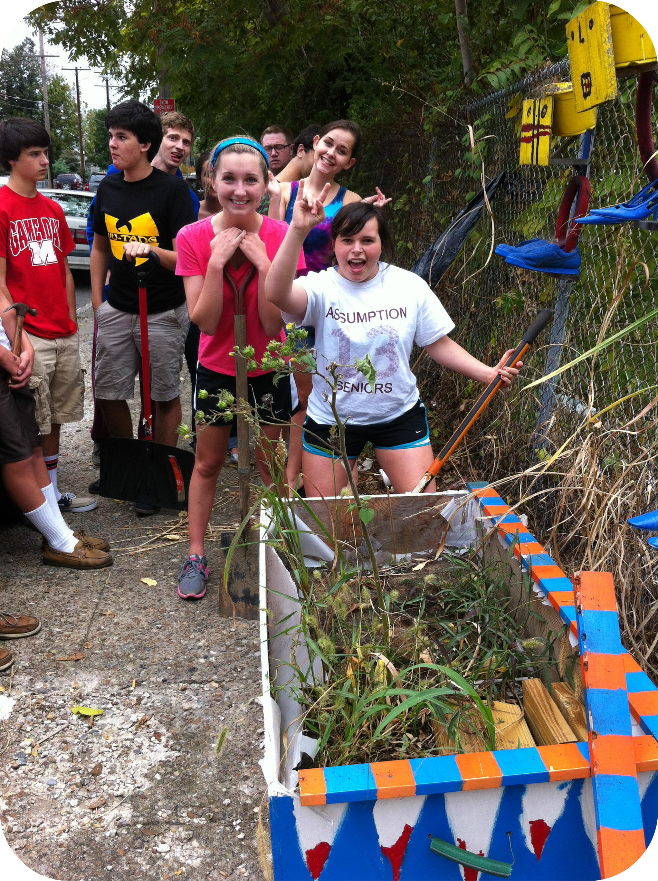
- Chair each meeting
*Clubs may choose to have a Vice President or a President Elect

Secretary
The secretary will work closely with the President and advisor to set service and registration deadlines for the year. This person will capture all notes from the meeting and report out to members who are unable to attend.
-Responsibilities
- Set deadlines
- Record and send out meeting minutes
- Track attendance

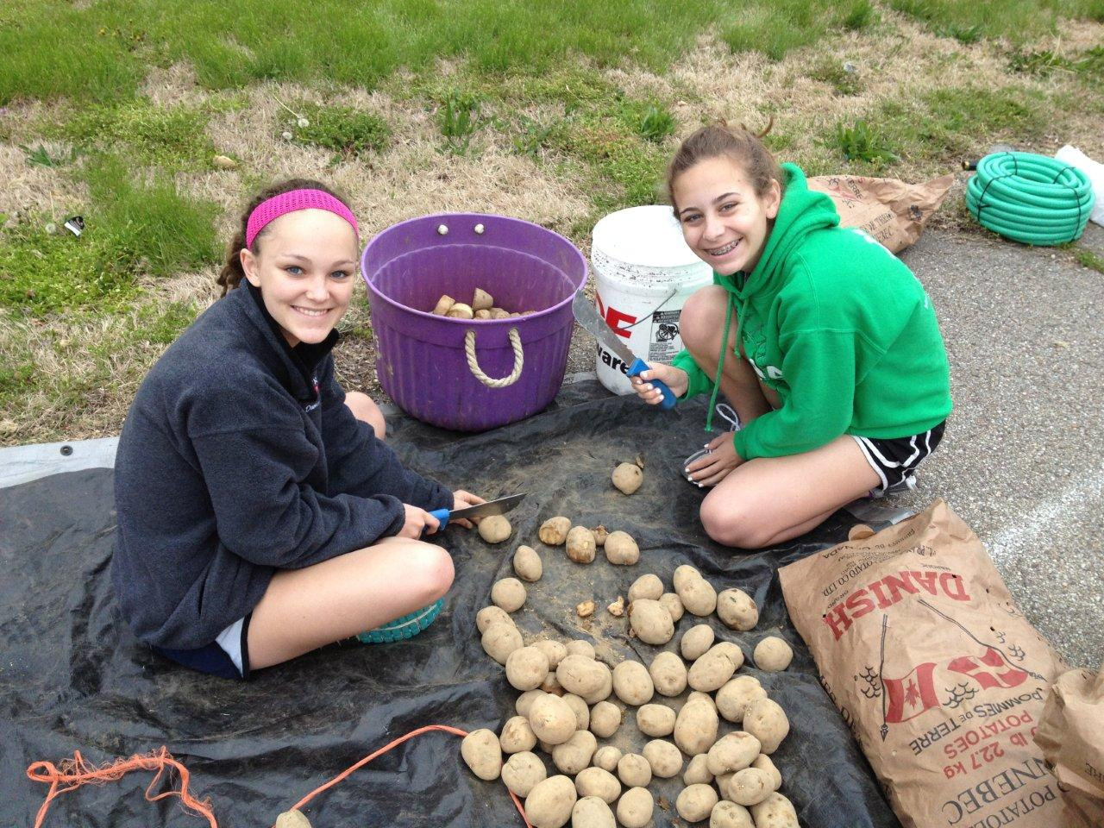
Treasurer
The treasurer is responsible for maintaining Student Y dues, ensuring that KYA and KUNA members are up to date on their registration fees, and planning fundraising for the club
-Responsibilities
- Assist advisor with collecting Student Y dues and contact information
- Help advisor organize KYA and KUNA payment database
- Plan fundraising events for Student Y

Service Chair
The Service Chair is responsible for gauging the passions of all members in the club to form agreement around the local service project in the fall and the global project in the spring. This person should utilize the KY YMCA website to make sure service resources are being used.
-Responsibilities
- Work with youth members to form local and global projects
- Utilize service resources from www.kyymca.org
- Complete service report forms
- Work with closely Public Relations Chair to receive pictures and media for service report forms

Public Relations Chair
The Public Relations Chair will function as a communication director, school representative and KY YMCA liaison. This student will be responsible for photo/video documentation to be included in all service reports, as well as documentation of Student Y participation in KYA/KUNA and other community programs. This media may then be distributed via school-approved Twitter accounts, school newspapers and local news outlets.
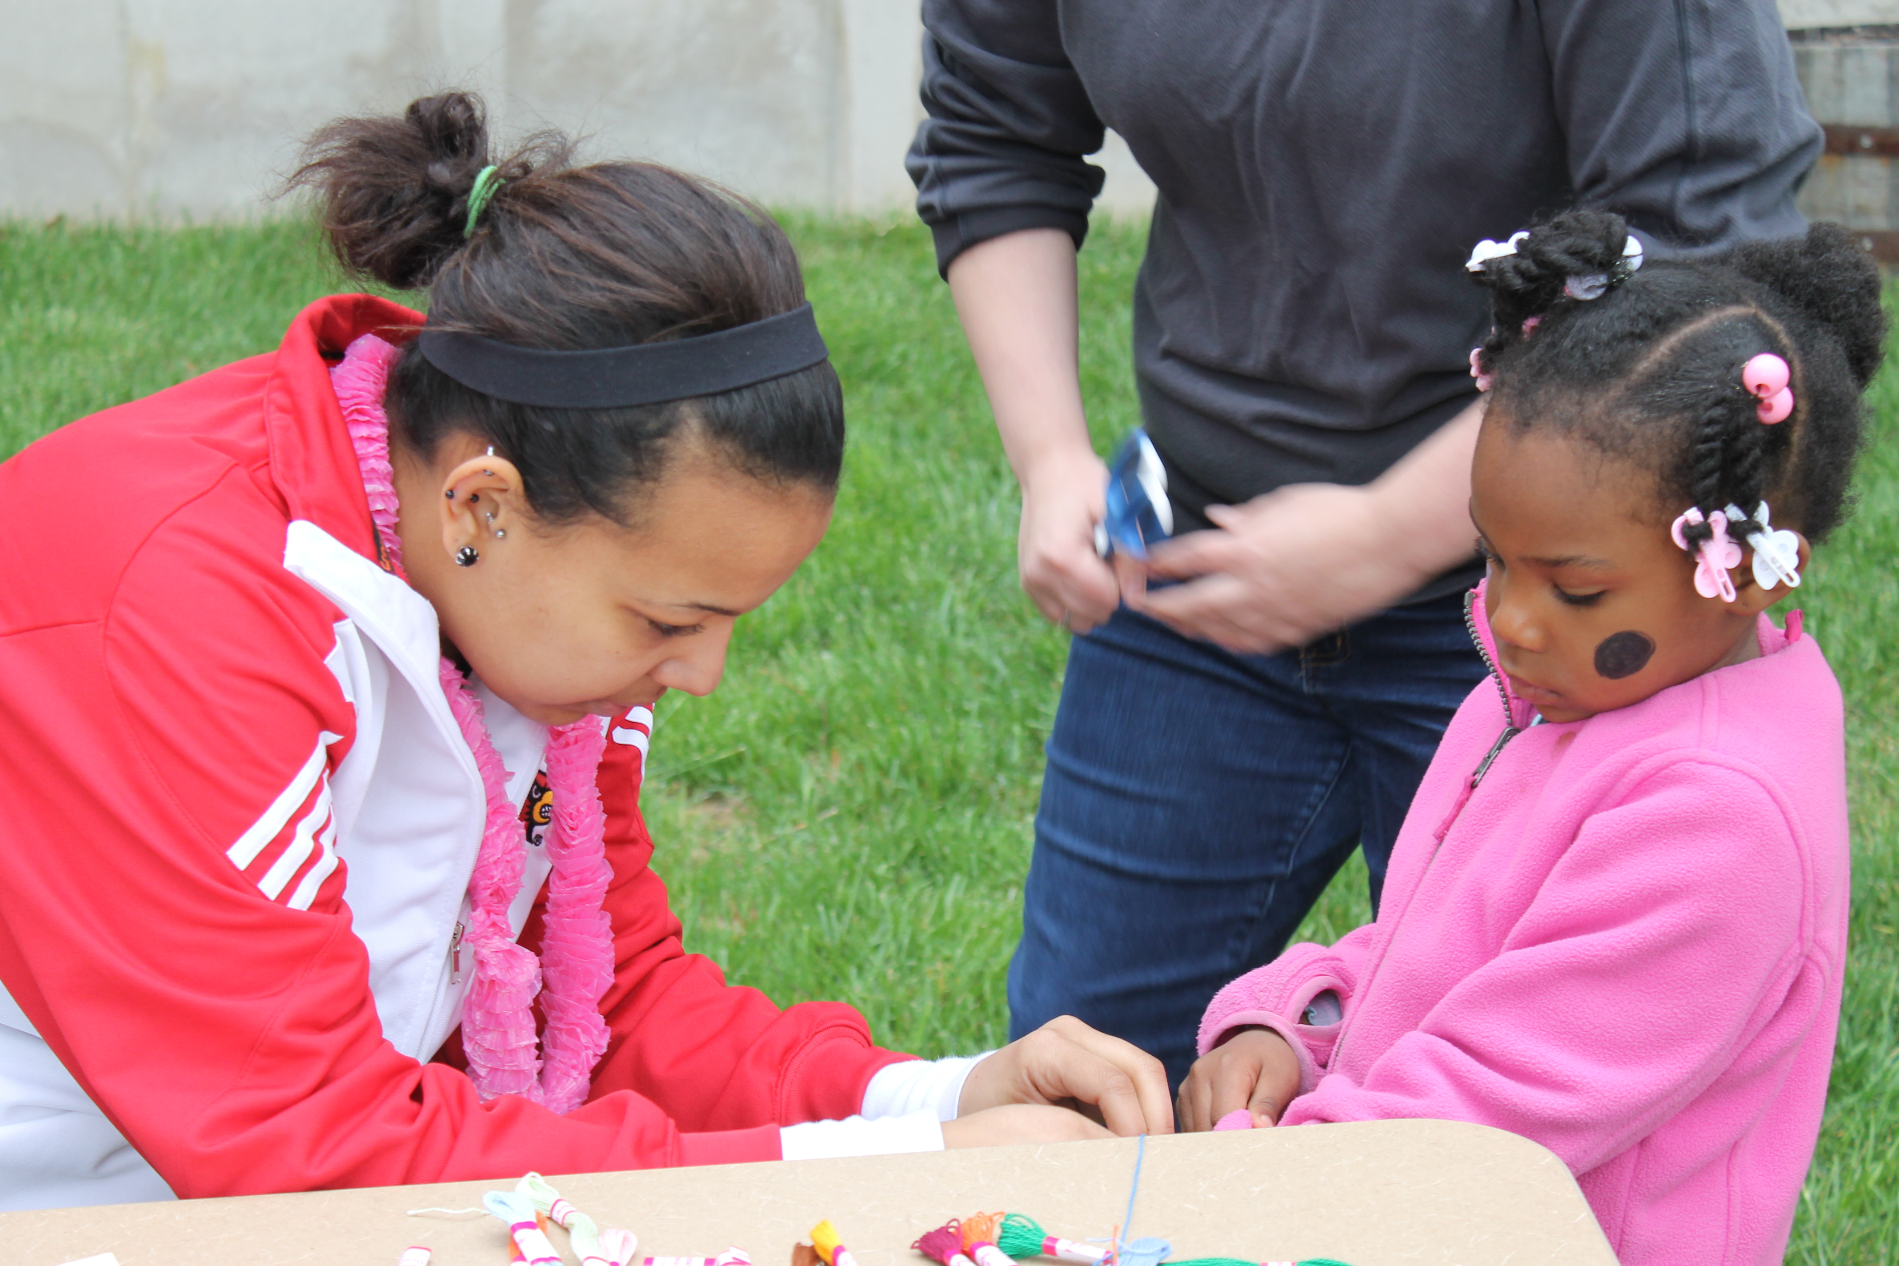
-Responsibilities:
- Photo documentation of meetings, events, service and conference participation
- Blogging for KY YMCA, school news source and local news source
- Optional: managing club Twitter/Instagram/Facebook page to promote service, recruitment and opportunities

Calendar of Events

October
- WeDay sign-ups (for interested Student Y Clubs)
- KY YMCA Recommended Fall Project: Halloween for Hunger http://halloweenforhunger.webs.com/

November
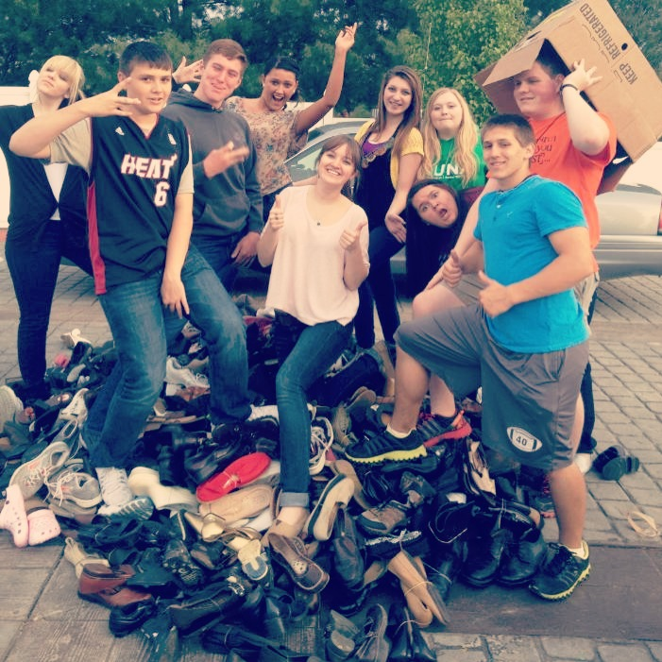
- November 11 last day to submit online service report form to be eligible for fall service awards http://kyymca.org/student-y/service-report-form
- Kentucky Youth Assembly
- Fall Service Awards Announced at KYA
December
- Kentucky Youth Assembly
- Happy Holidays! Make someone smile through a small act of kindness.

January
- January 6 Y-Corps Application Due
- Happy New Year!
- January 17-20 MLK Day of Service www.mlkday.gov

February
- February 28 last day to submit online service report form to be eligible for spring service awards
- KY YMCA Recommended Spring Project: Shoe Drive for WaterStep

March
- Kentucky United Nations Assembly (Donate your shoes here)
- Spring Service Awards announced at KUNA

April
- KY YMCA Recommended Service Project and Celebration: Global Youth Service Day April 11-13 http://www.gysd.org/gysd2014
- April 22 Earth Day
- April 23 last day to submit online service report form to be acknowledged as a Global Youth Service Day participant/club
- WeDay Celebration (for participating Student Y Clubs)

May

- KY YMCA Recommended Student Y Election Period
- Please complete all online service report forms before school is out!
- May 9 Student Y end of the year survey due

June-July
- Enjoy a summer filled with service!
- Y-Corps

August-September
- Create meeting schedule for the semester
- Recruit new members
- Complete Student Y Affiliation From on KY YMCA website http://kyymca.org/student-y/student-y-affiliation-form
- Pay Student Y dues
- Plan Fall Local Service Project
- 9/11 Day of Service

Service Awards (Fall and Spring)
The Kentucky Y is aware that many of our Student Y Clubs are participating in amazing acts of service each day and we want to begin acknowledging the great work being done. In the 2013-2014 school year Student Y clubs can be recognized at the Kentucky Youth Assembly and at the Kentucky United Nations Assembly. In the future we hope to continue the fall and spring awards at KYA and KUNA, but also introduce a separate service banquet for schools who participate in Student Y.
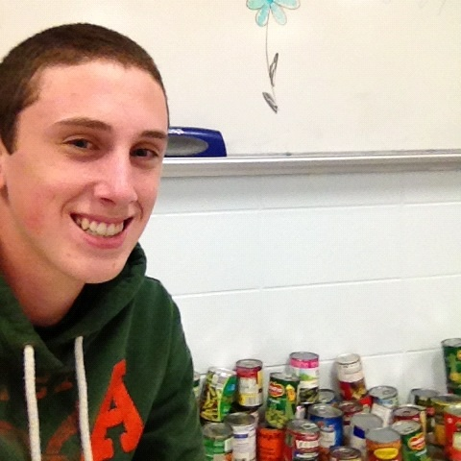
*To be eligible for a service award in the 2013-2014 school year you must be a registered and paid Student Y Club and submit all service projects correctly on the KY YMCA online service report form by the appropriate date. The awards to be given at KYA and KUNA this year are:

Innovative service project:
This award will go to Student Y Clubs who think outside of the box for their service projects. We are looking for unique ideas that encompass the goals of Student Y while engaging volunteers in a fun way.

Service partnership with an outside group
We love partners, and want to recognize the power in numbers and resources! Partners are able to provide service resources to your club and also new ideas. Describe your unique partnerships to us in your service report form and you may be eligible for this award!

Outstanding Student Awards
This is a very special award that will go to outstanding students within their Student Y Clubs. These students must emphasize the Y’s core values while also being active servant leaders in their community. Advisor and students are able to make nominations to Y staff for this award.

Service promotion
We want congratulate clubs for the creative ways that they advertise service projects and their club. All media will be considered for this award (social media, newspapers, radio, video, etc.). Make sure to inform your RD of your social media site so that we can see the great work you are doing!

