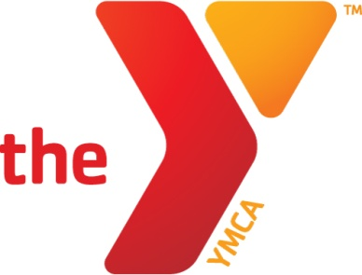 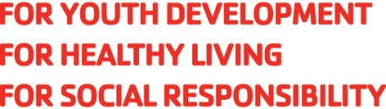

Regional Director Application Process

Thank you for your interest in a position with the Kentucky YMCA Youth Association. The selection process consists of:

1. By June 23:
   1. Your completed online application
   2. Submitted cover letter, resume, and three (3) references (two work, one personal)
2. If you are selected, you will be interviewed by three staff members by phone or in person between June 25-July 1.
3. Face-to-face interviews will be held July 7-11.
4. Notification of hiring decision by July 17.

We look forward to receiving your application and exploring the possibility of your employment with the Kentucky YMCA.

Kentucky YMCA Youth Association

P.O. Box 4285

Frankfort, KY 40604

502.227.7028

FAX 502.227.7030

www.kyymca.org