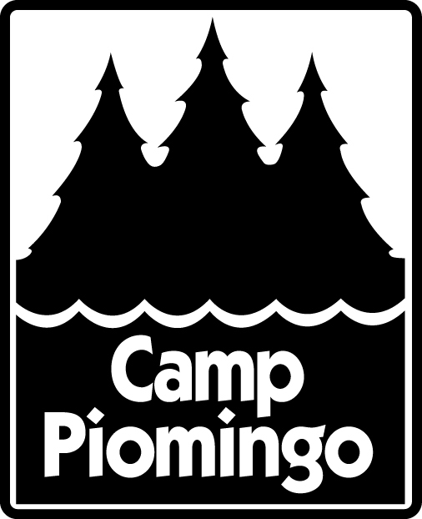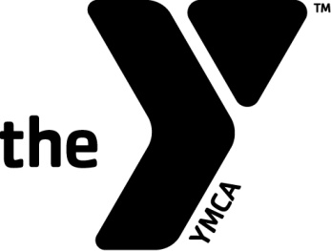YMCA of Greater Louisville

545 South Second Street

Louisville, KY 40202

(P) 502 587 9622

**YMCA CAMP PIOMINGO**

**GENERAL RELEASE OF LIABILITY FOR HIGH RISK ACTIVITIES**

**2018**

PLEASE RETAIN A COPY OF THIS FORM FOR YOUR RECORDS!

PARTICIPATION AGREEMENT/ASSUMPTION OF RISK & RELEASE:

Please READ & SIGN this Statement. Incomplete forms will be returned.

• Whereas, the undersigned (the “Applicant”) wishes to be accepted for participation in all camp activities including “High Risk” activities if scheduled,conducted by YMCA of Greater Louisville Camp Piomingo, and in consideration of YMCA of Greater Louisville Camp Piomingo action in allowing the Applicant to participate in such program.

• The undersigned acknowledges that during the said activities that the Applicant isrequested to participate in, that certain risks and dangers may occur. These include but are not limited to the hazards of depending on other people and being at various heights (ground to 50’), accident or illness in remote places without medical facilities, the forces of nature and travel by air, train, boat, automobile or other conveyance. The undersigned further recognizes risks may also include loss or damage to personal property, physical or psychological damage and/or injury not excluding fatality due to accidents which may occur, including accidents resulting from this challenge course experience or other type of outdoor activities. I further understand that in participating in the activities I am requesting to participate in, I could be exposed to the elements of nature, including temperature extremes, and inclement weather. I further understand that medical treatment may be several minutes to hours away in the event of a medical emergency.

• In consideration of and a part of payment for the right to participate in such a program and the services and food arranged for me by YMCA of Greater Louisville Camp Piomingo, its board of Management, Officers, Employees, Agents, and/or Associates I have and do hereby assume all the above risks and any other ordinary risk incidental to the nature of the program, including risks which are not specifically foreseeable, and will hold them harmless from any and all liability, actions, causes of action, debts, claims and demands of every kind and nature whatsoever, whether for bodily injury, property damage or loss or otherwise, which I now have or which may arise from or in connection with my program or participation in any other activities arranged for me by YMCA of Greater Louisville Camp Piomingo, its board of Management, Officers, Employees, Agents, and/or Associates, and their heirs, executors and administrators. The terms hereof and my signature on this document shall bind my heirs, representatives, executors, and administrators, successors, and assigns and for all members of my family, including any minors accompanying me. I also state that I am not under, and will not be under the influence of any chemical substance including alcohol. I fully understand that any physical activity involves risk of injury. I also understand that my participation in the YMCA of Greater Louisville Camp Piomingo program is entirely voluntary and that I may excuse myself from participation if I so desire.

• I hereby enroll in YMCA Camp Piomingo Programming. In signing this application, I certify that he/she is healthy and free of problems that could adversely affect his/her stay or that of other campers at YMCA Camp Piomingo.

• I agree to pay the balance of camp fees on or before that fee is due. I understand that reserved spaces cannot be held without full payment.

• I grant permission for the applicant to participate in all planned camp activities. My child has permission to leave the YMCA Camp Piomingo grounds with authorized Camp Staff in authorized Camp vehicles for scheduled trips and outings. I fully understand the inherent risks involved in activities my child will be choosing or has already chosen. I, the parent/guardian, accept all risks including those activities preliminary and subsequent to the chosen activities.

• I hereby grant the YMCA Camp Piomingo and its agents full authority to take whatever actions they deem necessary regarding my child’s health and safety, and I fully release YMCA Camp Piomingo from any liability in connection there within. I understand that prudent attempts will be made to contact the undersigned immediately. I understand that there is no accident or medical insurance provided and that I will be responsible for payment of all medical and medication bills. Parents will be expected to pre-pay any medical office co-pays and for any prescriptions picked up for their child while at camp.

• I understand that my child must comply with the camp’s rules and standards of conduct and that the organization may terminate my child’s participation in the camp program if he/she does not maintain these standards.

• I authorize YMCA Camp Piomingo, without limitation or obligation, to use photographs, film footage or tape recordings which may include my child’s image or voice for purposes of promoting or interpreting YMCA Camp Piomingo programs and release the camp from any claim or liability to that use.

• While YMCA Camp Piomingo will make every attempt to provide reasonable accommodations for mentally and physically challenged children, the camp will not accept children that are (1) of danger to themselves, (2) of danger to others, or (3) a disruption to the normal activities making it unreasonably difficult for other children to enjoy camp programs. Any of the above reasons will be grounds for dismissal from camp. A parent/guardian must discuss with the director any special conditions or circumstances involving their child. This must be done prior to registration so that we can advise you as to whether we can make a reasonable accommodation for your child.

• YMCA Camp Piomingo is not responsible for lost, stolen or damaged personal articles.

Name of Participant _______________________________

(Please Print)

Signature of Parent or Guardian _______________________________ Date_____________

Signature of Witness ________________________________________Date_____________