NAME_________________

*He sprinkled me in pixie dust and told me to believe*

**

*Believe in him and*

*believe in me*

*Together we will fly away in a cloud of green*

*To your beautiful destiny*

What is Your Y-Pal’s Favorite…

(Feel free to draw!)

Color?

Place to Go?

Y Conference?

Food?

Memory?

Sport?

Believe In…

Leadership

What makes a leader impactful?

Who do you look towards for leadership?

How can you become a better leader?

Draw Yourself as Your Ideal Leader

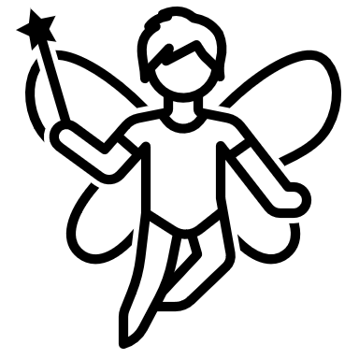Theme

Reflection

Believe In…

Confidence

When are you expected to be confident **for** others?

When are you expected to be confident **in** others?



**Fill your mirror with compliments**

Candyconomy

_________________________________________________________________________________________

_________________________________________________________________________________________

RECEIPT

RECEIPT

Believe In…

Fairness

What are things in your life that are unfair?

Where do you see unfairness in the lives of others?

What can you do about this unfairness?

Believe In…

Balance

Do you have a balanced life? How so?

How can you strive for more balance?

What is the difference between Equity and Equality?

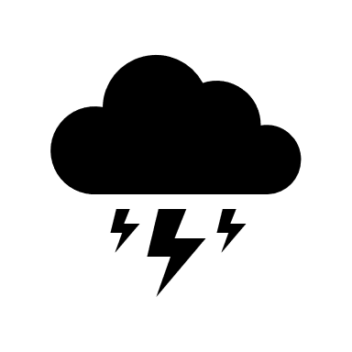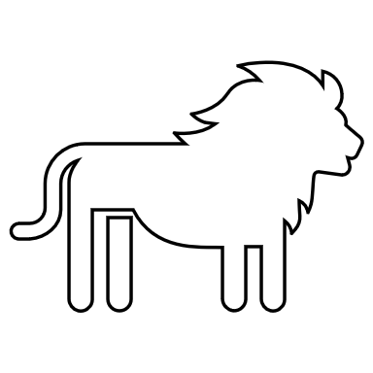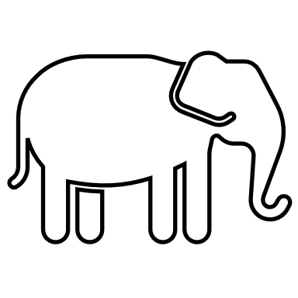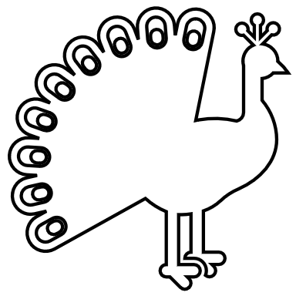

**DON’T ROCK**

**THE BOAT**



_____________________________________________________________________________________________________________________________________________________________________________________________280



What will your message be?

_____________________________________________________________________________________________________________________________________________________________________________________________280

Believe In Us